FAANG Companies interview preparation
“FAANG” is an acronym that refers to the five prominent American technology companies: Facebook (FB), Amazon (AMZN), Apple (AAPL), Netflix (NFLX); and Alphabet (GOOG) (formerly known as Google)
- Go through all topics in algodaily.com
Link: https://algodaily.com/lessons/how-to-prepare-for-a-technical-interview

Cover all topics on left hand side menu on this site:
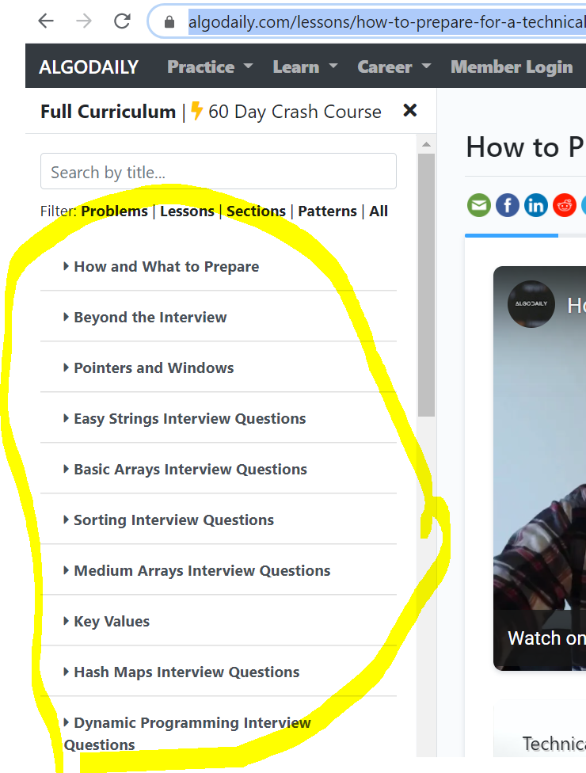
- Solve 25 to 30 top leet code problems. Target Easy or Medium level problems.
- You can also refer medium.com to find top50 coding problems. [Optional]
Example link:
https://medium.com/@koheiarai94/60-leetcode-questions-to-prepare-for-coding-interview-8abbb6af589e

If you cover the above 3 things, you will gain lot of confidence in approaching any coding problem.
Now, the next steps are company related preparation. Example if you are preparing for Amazon, look for most frequently asked questions for Amazon. Same thing goes for other companies like Facebook or etc.
- Solve company related frequently asked coding questions:
https://www.geeksforgeeks.org/amazon-interview-questions/
- Follow the youtube channel(s) for company related coding questions and solutions:
https://www.youtube.com/c/KevinNaughtonJr/playlists

Key Points:
- Try to spend at least an hour or two in solving coding problems. Keep solving at least one or two questions.
- Don’t lose the momentum because we tend to forget the concept. So, daily preparation is important.
- You can glance over already existing solutions but code at least one problem in any IDE or online coding platform.

